**SQL ASSIGNMENT**

**Name:** Abhishek

**Date: -** 24 June,2025

**Exercise 1:** Using the AdventureWorks database, perform the following queries.

1. Display the number of records in the [SalesPerson] table. (Schema(s) involved:

Sales)

1. Select both the FirstName and LastName of records from the Person table where the FirstName begins with the letter ‘B’. (Schema(s) involved: Person)

1. Select a list of FirstName and LastName for employees where Title is one of Design Engineer, Tool Designer or Marketing Assistant. (Schema(s) involved: HumanResources, Person)

1. Display the Name and Color of the Product with the maximum weight. (Schema(s) involved: Production)

1. Display Description and MaxQty fields from the SpecialOffer table. Some of the MaxQty values are NULL, in this case display the value 0.00 instead. (Schema(s) involved: Sales)

1. Display the overall Average of the [CurrencyRate].[AverageRate] values for the exchange rate ‘USD’ to ‘GBP’ for the year 2005 i.e. FromCurrencyCode = ‘USD’ and ToCurrencyCode = ‘GBP’. Note: The field [CurrencyRate].[AverageRate] is defined as 'Average exchange rate for the day.' (Schema(s) involved: Sales)

1. Display the FirstName and LastName of records from the Person table where FirstName contains the letters ‘ss’. Display an additional column with sequential numbers for each row returned beginning at integer 1. (Schema(s) involved: Person)

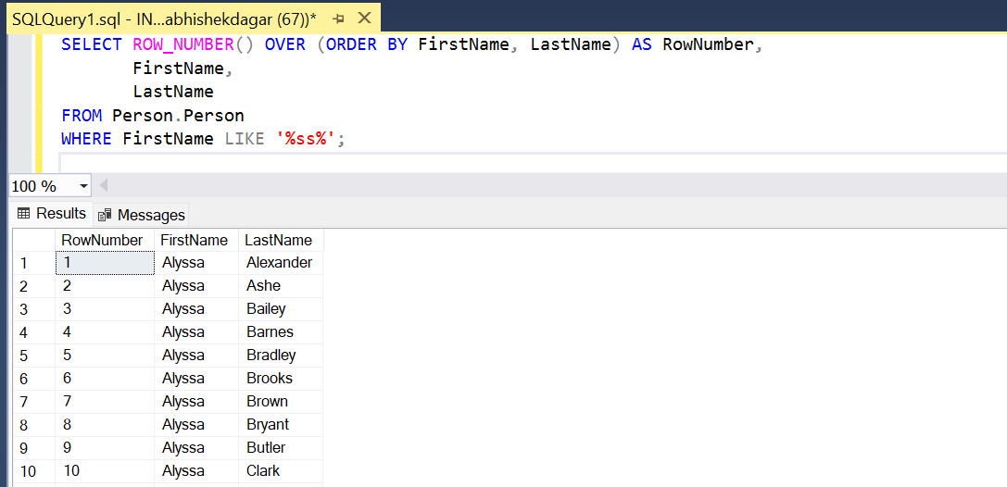

1. Salespeople receive various commission rates that belong to 1 of 4 bands. (Schema(s) involved: Sales)

Display the [SalesPersonID] with an additional column entitled ‘Commission Band’ indicating the appropriate band as above.

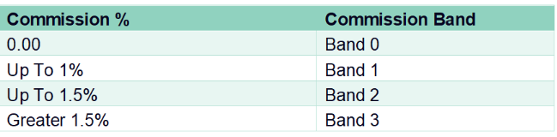

1. Display the managerial hierarchy from Ruth Ellerbrock (person type – EM) up to CEO Ken Sanchez. Hint: use [uspGetEmployeeManagers] (Schema(s) involved: [Person], [HumanResources])

1. Display the ProductId of the product with the largest stock level. Hint: Use the Scalar-valued function [dbo]. [UfnGetStock]. (Schema(s) involved: Production)

**Exercise 2:** Write separate queries using a join, a subquery, a CTE, and then an EXISTS to list all AdventureWorks customers who have not placed an order.

*Approach 1: Using LEFT JOIN*

*Approach 2: Using SUBQUERY*

*Approach 3: Using CTE (Common Table Expression)*

*Approach 4: Using EXISTS*

**Exercise 3:** Show the most recent five orders that were purchased from account numbers that have spent more than $70,000 with AdventureWorks.

**Exercise 4:** Create a function that takes as inputs a SalesOrderID, a Currency Code, and a date, and returns a table of all the SalesOrderDetail rows for that Sales Order including Quantity, ProductID, UnitPrice, and the unit price converted to the target currency based on the end of day rate for the date provided. Exchange rates can be found in the Sales.CurrencyRate table.

**Exercise 5:** Write a Procedure supplying name information from the Person.Person table and accepting a filter for the first name. Alter the above Store Procedure to supply Default Values if user does not enter any value.

**Exercise 6:** Write a trigger for the Product table to ensure the list price can never be raised more than 15 Percent in a single change. Modify the above trigger to execute its check code only if the ListPrice column is updated

**Create Trigger: -**

**Test**

**Alter Trigger: -**

**Test**

**Note: -**Some screenshots are cut in between of table because of limited screen size capture